Questions 2 and 3:

|  |  |
| --- | --- |
| Original | K=4 |
| K=8 | K=16 |

For Ayers, K=16 and K=8 are both acceptable, with only slight damage to the clouds and grass.

For Neyland, All K values retain a high amount of recognizability, though K=8 and K=4 both lose the green of the field.

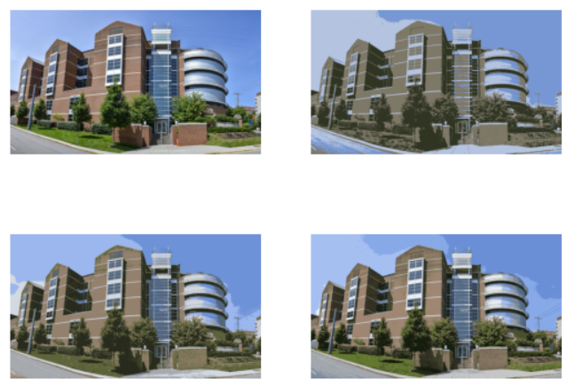All K values of Min Kao look very similar, but K=4 loses both the road and the different coloration of the windows, and I would not count it as acceptable.

K=4 in the smokey image loses all semblance of coherency in the background, as well as blending smokey into it, as such it is the only unacceptable K value.